Stage 1 — Concept 1: What exactly is rPPG?
rPPG = remote Photoplethysmography.
Let's break the word down:
- Photo → light
- Plethysmography → measuring changes in blood volume
- Remote → measuring it without touching the person
So:
rPPG is a technique that uses a camera to estimate changes in blood volume underneath the skin.
And from those changes, we can estimate heart rate.

🫀 First: What does a normal PPG do?
You've probably seen the sensor on a smartwatch.
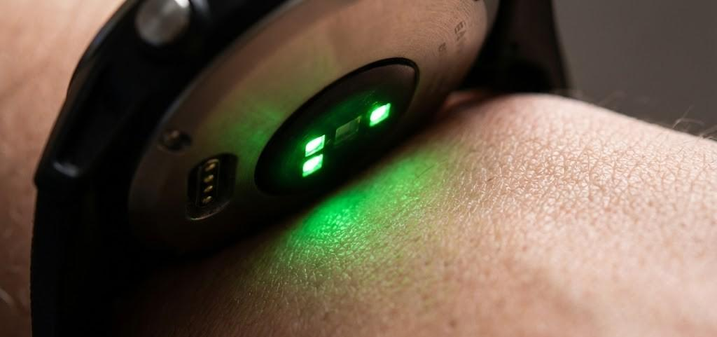
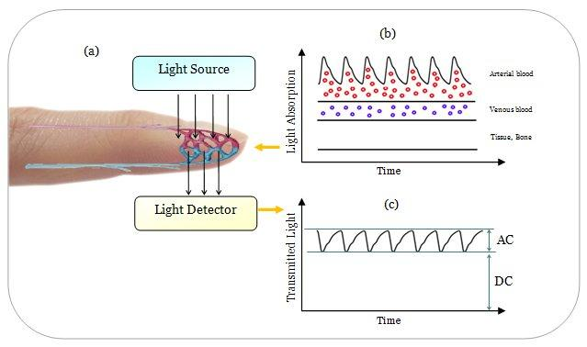
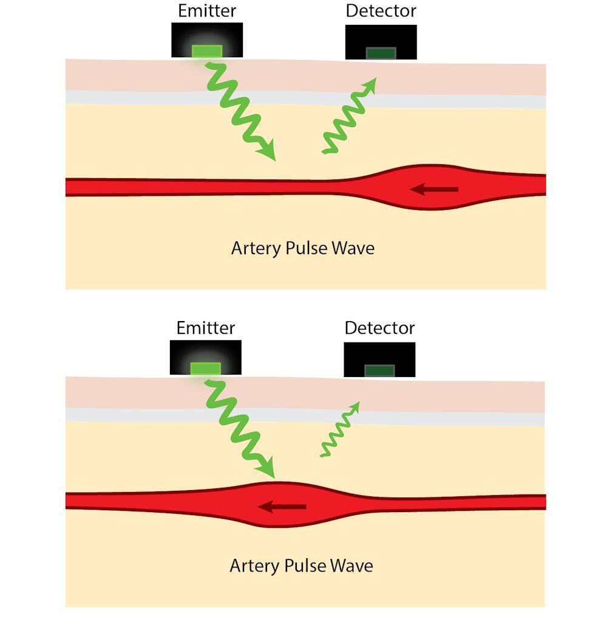
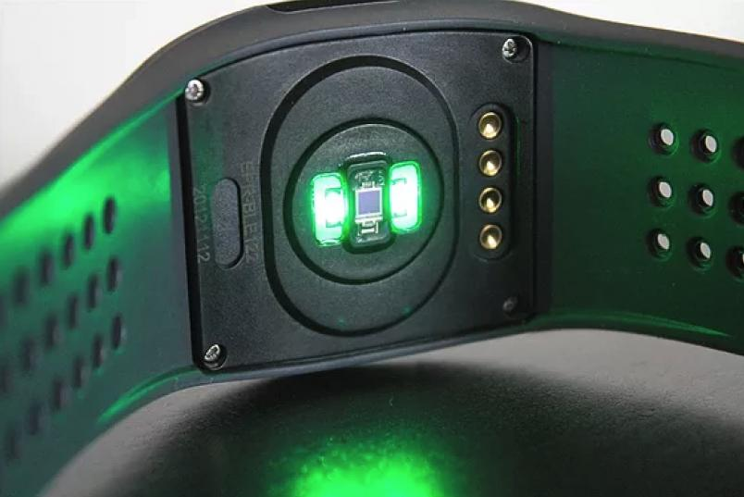
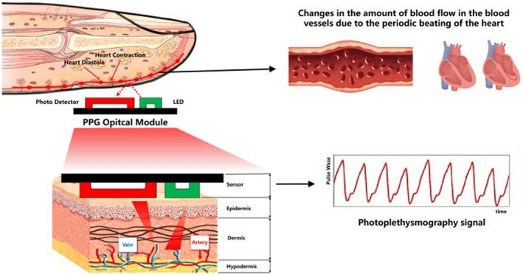
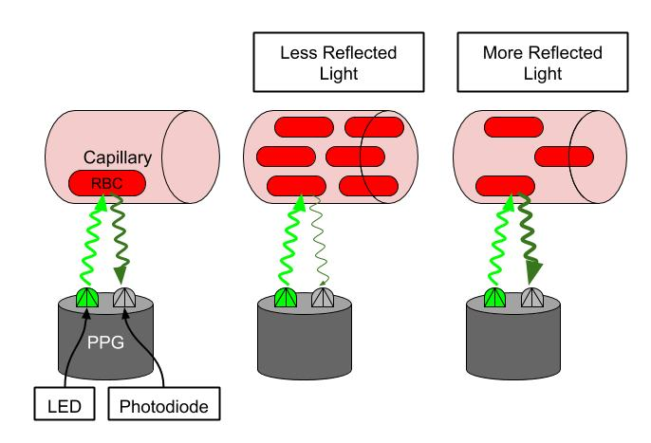
A smartwatch shines light onto your skin.
When your heart beats:
Heart contracts → blood flows into the skin → blood volume slightly increases
Then:
Heart relaxes → blood volume decreases
So the amount of light absorbed/reflected by the skin changes slightly.
The sensor detects this repeating change.
That is PPG.

📷 Now remove the physical sensor
Instead of:
LED + photodiode touching your skin
we use:
RGB camera + light already present in the environment
That's rPPG.
Imagine this:
HEART
↓
Blood circulation
↓
Tiny skin-color changes
↓
RGB CAMERA
↓
Extract facial region
↓
Analyze color changes
↓
Pulse waveform
↓
Heart Rate
The important idea is:
Your face isn't visibly turning red and white with every heartbeat. The changes are extremely tiny.
A camera records enough frames over time that we can mathematically extract those tiny variations.

🧠 But how can blood affect skin color?
This is the important intuition.
Your blood contains hemoglobin.
Hemoglobin absorbs certain wavelengths of light.
When the amount of blood underneath your skin changes slightly:
Heartbeat
↓
More blood in facial blood vessels
↓
Slightly different light absorption
↓
Slightly different RGB values
For example, suppose we look at a small forehead region.
One frame:
R = 145
G = 112
B = 98
A moment later:
R = 144
G = 114
B = 98
Those changes are tiny.
But if they happen periodically:
RGB value

/\ /\ /\
/ \ / \ / \
____/ \___/ \___/ \____
That periodic pattern can contain the heartbeat information.

🎥 Why video is necessary
A single image cannot tell us your heart rate.
We need many images over time.
Suppose our webcam captures at:
30 FPS
That means:
30 frames every second
In 10 seconds:
30 × 10 = 300 frames
We can track the average color of the same facial region across those 300 frames.
So instead of looking at:
"What color is the face?"
we ask:
"How does the face's color change over time?"
That's the key transition from computer vision → signal processing.

📈 What we ultimately want
Imagine we extract one signal from the face:
Time →

/\ /\ /\
/ \ / \ / \
____/ \____/ \____/ \____
This is our rPPG signal.
The periodicity corresponds approximately to the heartbeat.
If we find that the heart is beating approximately 1.2 times per second:
1.2 beats/second × 60
= 72 beats/minute
So:
Frequency → BPM
We'll later learn exactly how we extract that frequency using filtering + FFT.

⚠️ The big problem: Noise
Here's where the project becomes interesting.
The camera doesn't see only blood-related changes.
It also sees:
Face movement
Lighting changes
Head rotation
Camera noise
Facial expressions
Shadows
Skin tone
Compression
For example, if you move your head:
Camera sees a HUGE change
while the heartbeat might produce:
Camera sees a TINY change
So our job is essentially:
Find the tiny periodic physiological signal buried inside much larger visual noise.
That's why this project involves both:
Computer Vision
→ finding and tracking the right facial region
and
Signal Processing / Deep Learning
→ extracting the physiological information.

🎯 One important distinction
There are two approaches we'll eventually build:
Classical rPPG
Camera
↓
Face
↓
ROI
↓
RGB signal
↓
Filtering
↓
FFT
↓
Heart Rate
No neural network is required.
Deep-learning rPPG
Camera
↓
Face / video frames
↓
Neural Network
↓
Learn physiological patterns
↓
Pulse signal / HR
We'll start with the classical approach first.
That's important because if we jump directly into PhysNet/DeepPhys, you may get a model that works without understanding what the model is actually learning.

Stage 1 — Concept 2: What is PPG?
PPG = Photoplethysmography.
Don't worry about the name. The basic idea is very simple:
PPG measures changes in blood volume using light.
🫀 Imagine a smartwatch
A smartwatch has:
- 💡 LED → shines light onto your skin
- 📷 Photodetector → measures the light coming back
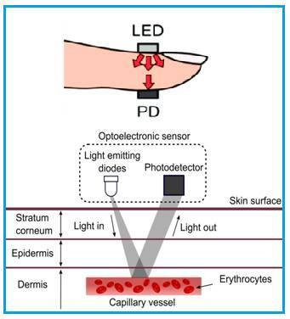
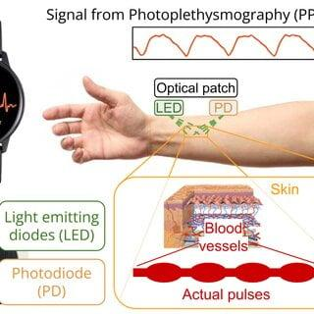
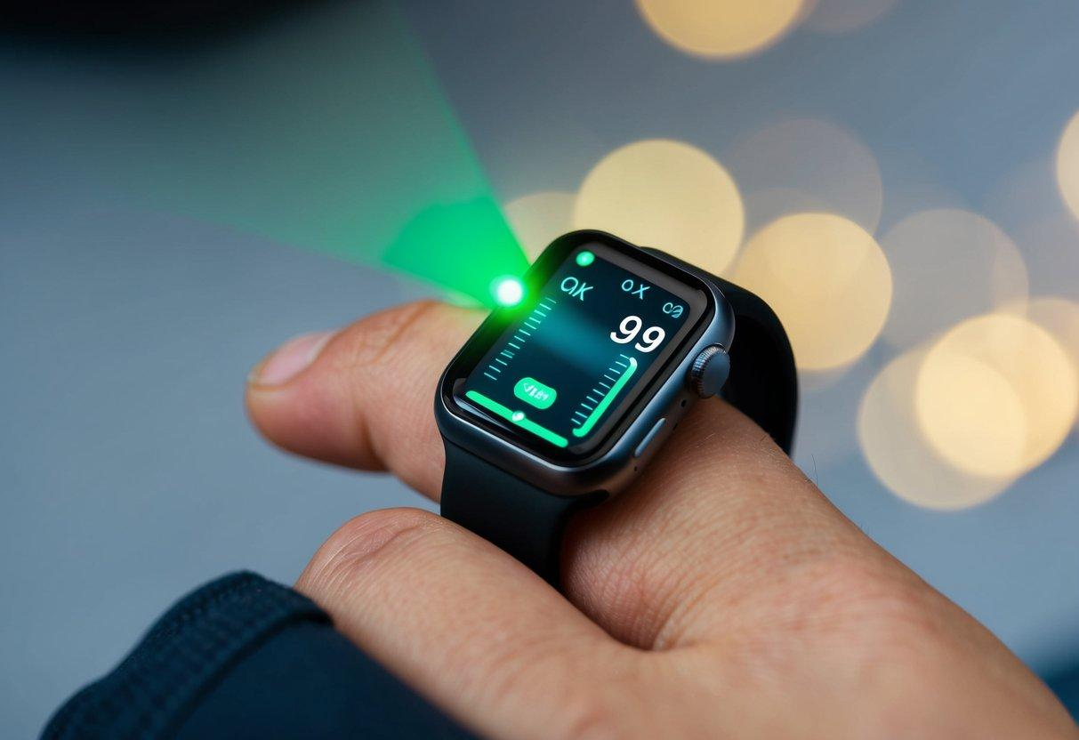
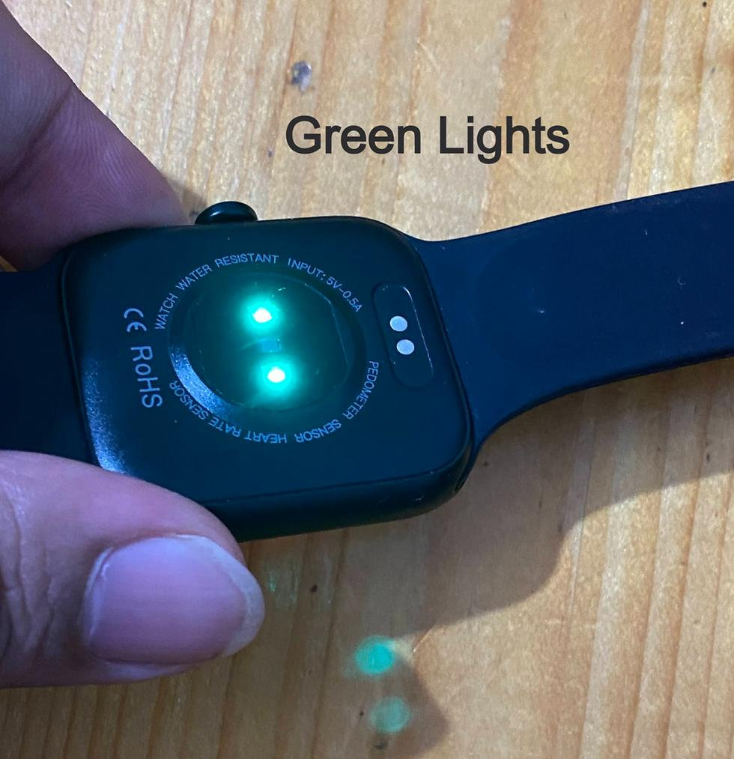
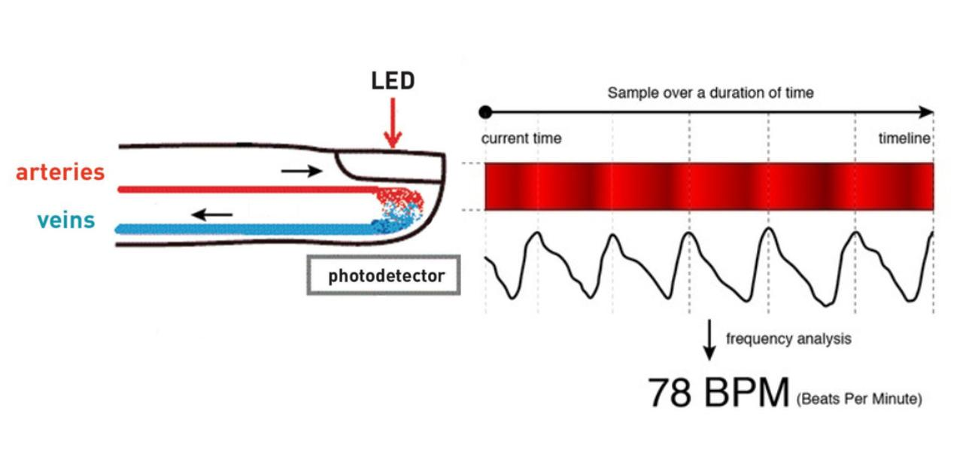
Now your heart beats.
Step 1 — Heart contracts
More blood enters the tiny blood vessels near your skin.
❤️ Beat
↓
More blood
↓
More light gets absorbed
↓
Less light reaches detector
Step 2 — Heart relaxes
Blood volume decreases slightly.
❤️ Relax
↓
Less blood
↓
Different amount of light absorbed
↓
More light reaches detector
So the sensor gets something like:
Light intensity
↑
│ /\ /\ /\
│ / \ / \ / \
│___/ \__/ \__/ \____
└──────────────────────────────→ time
That repeating waveform is the PPG signal.

🧠 The important part
Don't memorize:
"PPG uses green light."
That's not the fundamental concept.
Remember:
Blood volume changes → optical properties change → detected light changes → periodic signal.
The exact wavelength and sensor design can vary.

📷 Now connect PPG → rPPG
Here's the beautiful part.
Normal PPG
LED + photodetector
↓
Skin
↓
Blood-volume changes
↓
PPG signal
rPPG
Ambient light
↓
Face
↓
Blood-volume changes
↓
Tiny changes in reflected light
↓
RGB camera
↓
rPPG signal
So rPPG isn't a completely different phenomenon.
It's essentially trying to recover a PPG-like physiological signal remotely using a camera.

🧪 Tiny mathematical intuition
Suppose the camera observes the brightness of a skin region.
We can think of the observed signal approximately as:
[
I(t) = \text{baseline} + \text{pulse variation} + \text{noise}
]
For example:
I(t)
=
100 ← baseline skin brightness
+
0.5 sin(t) ← tiny pulse variation
+
noise ← movement/lighting/etc.
The crazy part?
The pulse variation might be much smaller than the other variations.
That's why signal processing becomes so important later.

Stage 1 — Concept 4: Why forehead and cheeks?
Now we're connecting the physiology to Computer Vision.
When the webcam sees your entire face, we don't want to use every pixel.
We need to choose a Region of Interest (ROI).
ROI = the specific part of the image we want to analyze.
For rPPG, common choices are:
- Forehead
- Left/right cheek
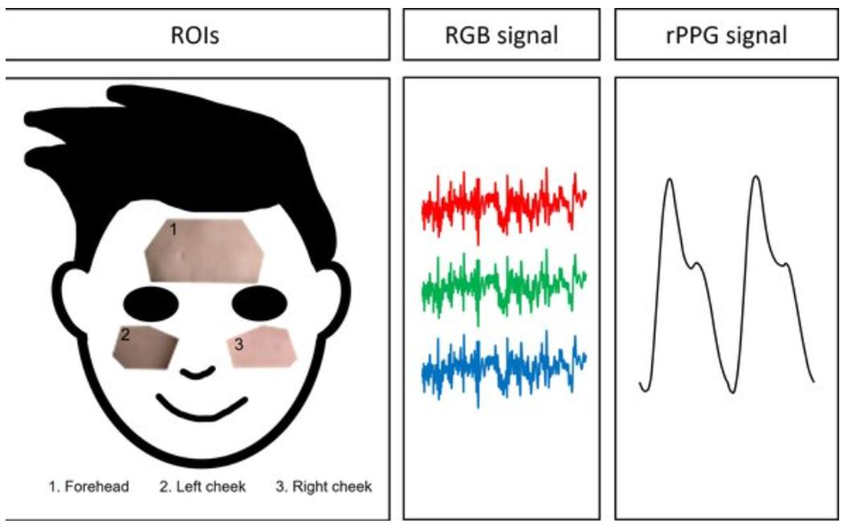
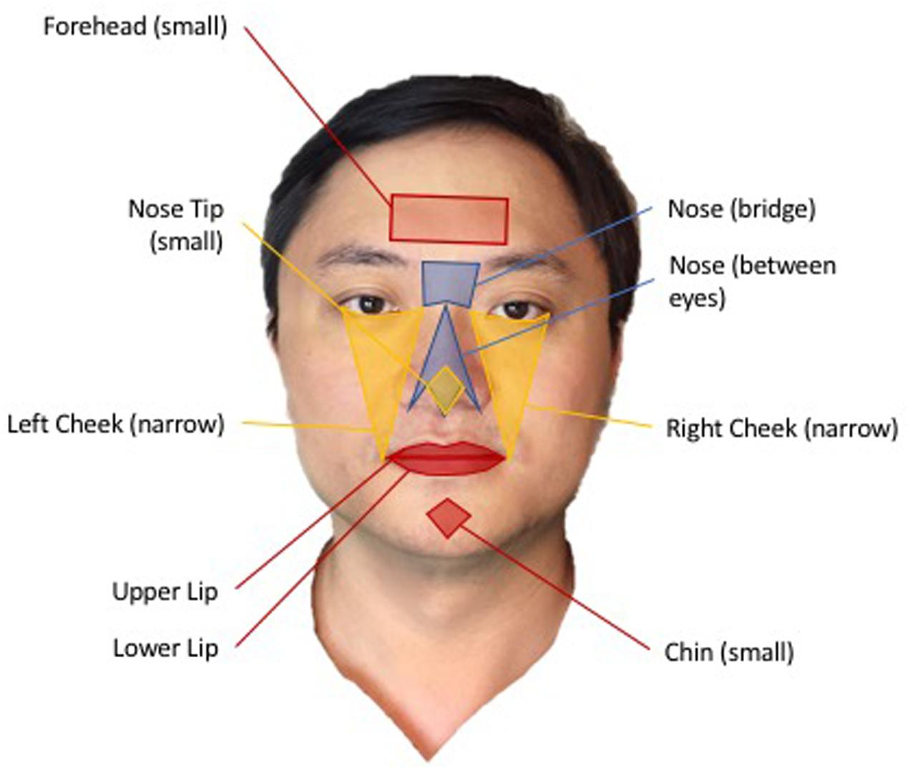
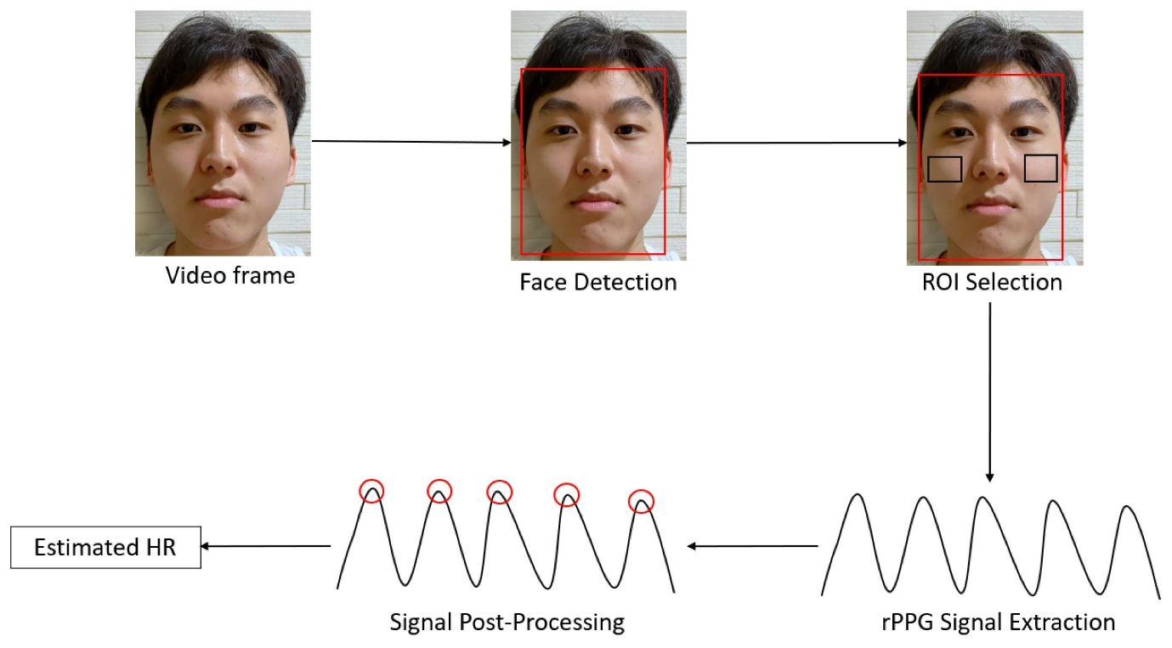
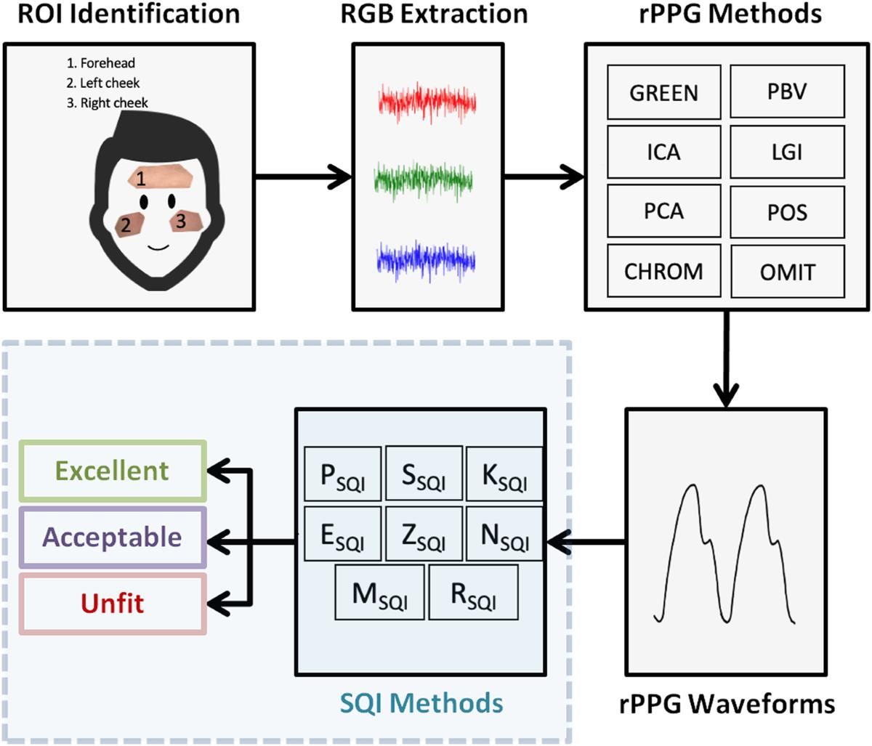
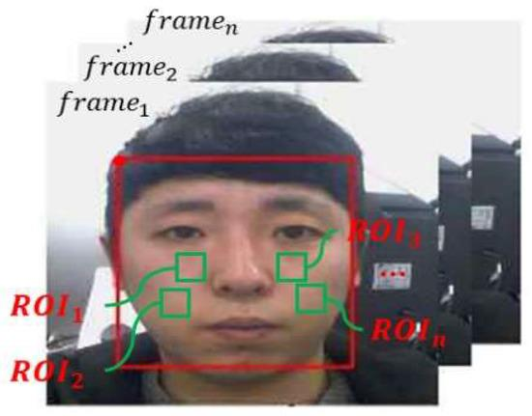

🧠 Why not use the whole face?
Imagine this:
FACE
┌─────────────┐
│ FOREHEAD │ ← useful
│ │
│ 👁 👁 │
│ │
│ 👃 👄 │ ← lots of movement
│ │
│ CHEEKS │ ← useful
└─────────────┘
Different parts of the face behave differently.
The eyes and mouth can move significantly.
For example:
Blink
↓
Large pixel changes around eyes
Talking
↓
Large pixel changes around mouth
Those changes aren't related to heartbeat.
So we prefer relatively stable skin regions.

🩸 Why forehead and cheeks?
They generally provide:
1. Exposed skin
We need visible skin for the camera to observe the optical changes.
2. Good blood perfusion
These regions contain blood vessels close enough to the skin surface for their optical effects to contribute to the signal.
3. Relatively stable regions
Compared with the mouth and eyes, they usually move less.
So they can provide a cleaner signal.

📦 What happens computationally?
Suppose our webcam gives us:
1920 × 1080 image
We detect the face.
Then we select something like:
Forehead ROI
┌──────────────────┐
│ │
│ forehead │
│ │
└──────────────────┘
Instead of analyzing thousands of individual pixels independently, we can calculate the average RGB value of the ROI.
For example:
Frame 1:
R = 143
G = 118
B = 105

Frame 2:
R = 144
G = 119
B = 105

Frame 3:
R = 143
G = 119
B = 104
Now we have a sequence:
Time →

R: 143 144 143 142 144 145 ...
G: 118 119 119 117 119 120 ...
B: 105 105 104 105 105 104 ...
These sequences are our raw color signals.
And this is a VERY important transition:
IMAGE
↓
ROI
↓
Average RGB
↓
TIME SERIES
↓
SIGNAL PROCESSING
We'll later implement exactly this pipeline.

⚠️ Important limitation
Forehead/cheeks aren't magically perfect.
If the person:
- turns their head
- talks
- smiles
- changes lighting
- has hair covering the forehead
- has strong shadows
the signal can become noisy.
That's why a good rPPG system needs robust ROI tracking + signal processing.

🎯 Quick test
Imagine we're building our system.
The webcam sees:
Face
↓
Forehead
↓
Eyes
↓
Nose
↓
Mouth
↓
Cheeks

